**Assignment No:-59**

Name:-Suryawanshi Sangramsingh Sambhaji

Batch: - Delta - DCA (Java) 2024 Date:-5/8/2024

**MYSQL QUESTIONS:**

CREATE TABLE employees (

id INT NOT NULL AUTO_INCREMENT,

first_name VARCHAR(255) NOT NULL,

last_name VARCHAR(255) NOT NULL,

department VARCHAR(255) NOT NULL,

salary INT NOT NULL,

hire_date DATE NOT NULL,

birthdate DATE NOT NULL,

PRIMARY KEY (id)

);

INSERT INTO employees (first_name, last_name, department, salary, hire_date, birthdate)

VALUES

('John', 'Doe', 'sales', 50000, '2022-01-01', '1980-01-01'),

('Jane', 'Smith', 'marketing', 60000, '2022-02-01', '1981-02-01'),

('Michael', 'Brown', 'engineering', 70000, '2022-03-01', '1982-03-01');

1. Write a query to select all the rows from the employees table.

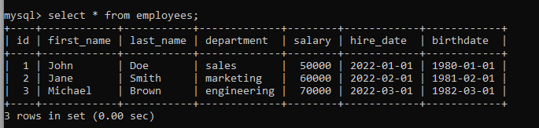

2. Write a query to select all the employees who are in the sales department.

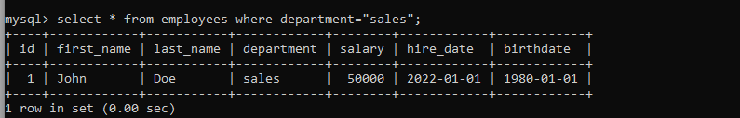

3. Write a query to select all the employees who have a salary greater than $50,000.

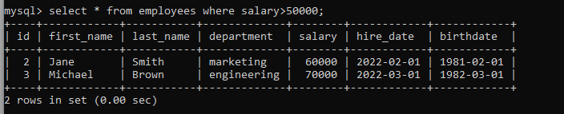

4. Write a query to select the average salary of all the employees.

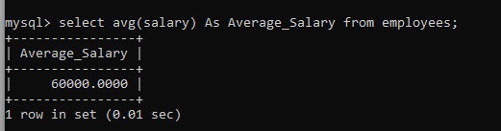

5. Write a query to select the highest and lowest salaries in the employees table.

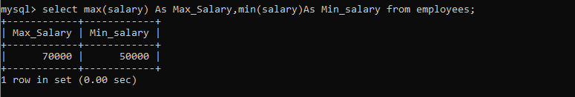

6. Write a query to select all the employees who were hired in the year 2022.

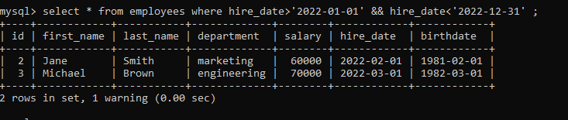

7. Write a query to select all the employees who have the same last name as you.

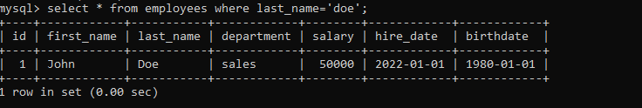

8. Write a query to select all the employees who are younger than you.

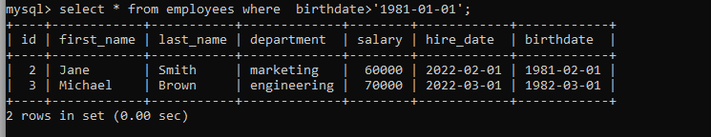

9. Write a query to select all the employees who are older than you.

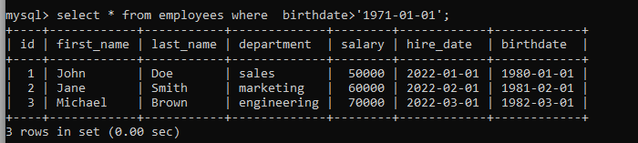

10. Write a query to select all the employees who are within 5 years of your age.

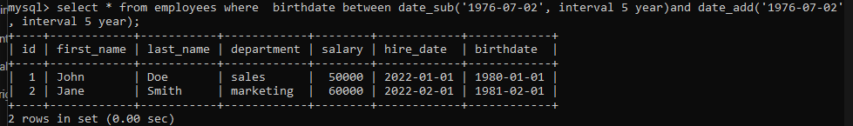

12. Write a query to select all the employees who have a salary between $50,000 and

$60,000.

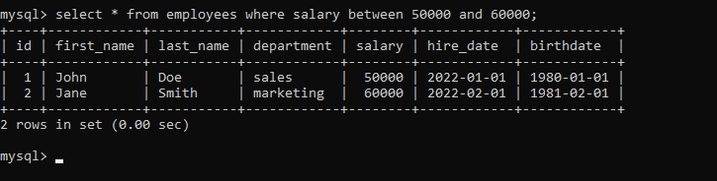

13. Write a query to select all the employees who were hired in the month of January

2022.

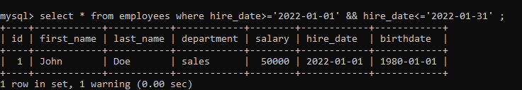

14. Write a query to select all the employees who have the same first name as you.

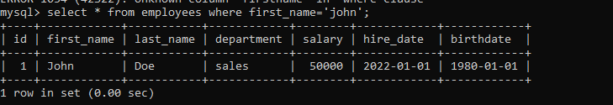

15. Write a query to select all the employees who are within 10 years of your age.

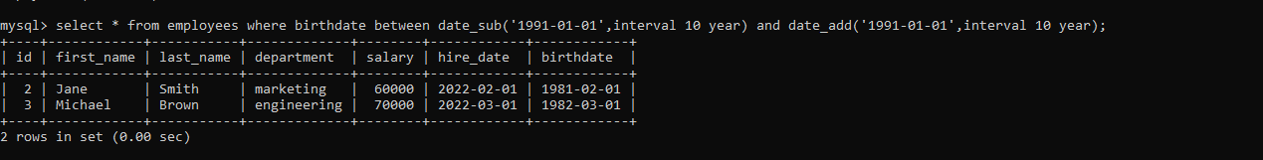

16. Write a query to select all the employees who are in the sales department and have a

salary greater than $50,000.

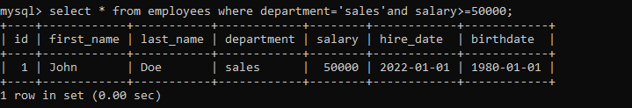

17. Write a query to select all the employees who are in the marketing department and

were hired in the year 2022.

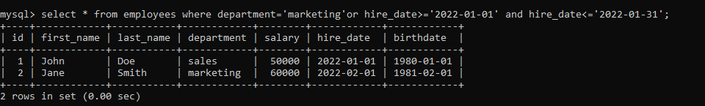

18. Write a query to select all the employees who are in the engineering department and

have a salary between $60,000 and $70,000.

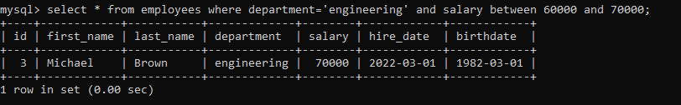

19. Write a query to select all the employees who are in the sales department or the

marketing department.

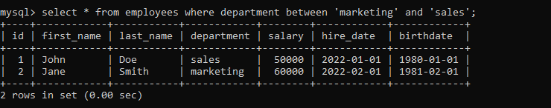

20. Write a query to select all the employees who are in the engineering department and

not in the sales department.

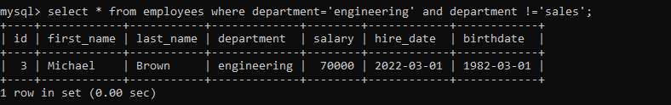

21. Write a query to select all the employees who are in the sales department, the

marketing department, or the engineering department.

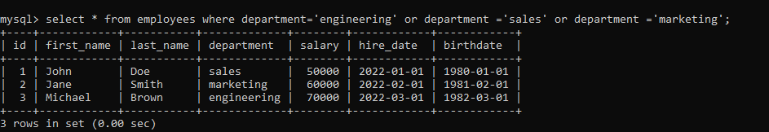

23. Write a query to select all the employees who have a salary greater than the average

salary.

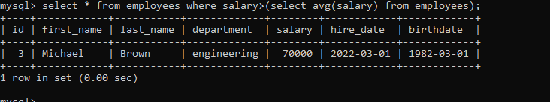

24. Write a query to select all the employees who have been with the company for more

than 5 years.

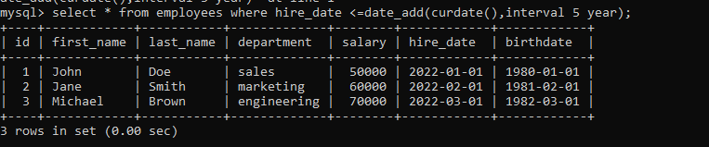

25. Write a query to select all the employees who have a last name that starts with the

letter "M".

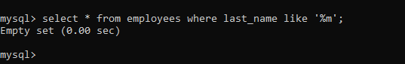

26. Write a query to select all the employees who have a first name that starts with the

letter "J" and a last name that starts with the letter "D".

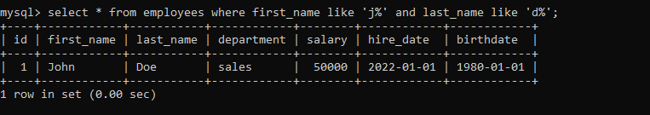

27. Write a query to select all the employees who have a salary greater than $50,000

and have been with the company for more than 5 years.

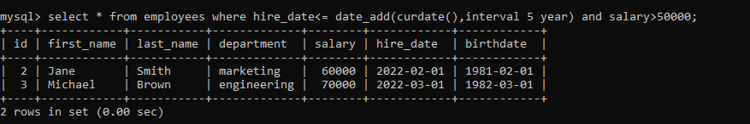

28. Write a query to select all the employees who have a last name that starts with the

letter "M" and are in the sales department.



29. Write a query to select all the employees who have a first name that starts with the

letter "J" and a last name that starts with the letter "D" and are in the marketing

department.



30. Write a query to select all the employees who have a salary greater than $50,000

and have been with the company for more than 5 years and are in the sales

department.



31. Write a query to select all the employees who have a last name that starts with the

letter "M" and are in the sales department or the marketing department.

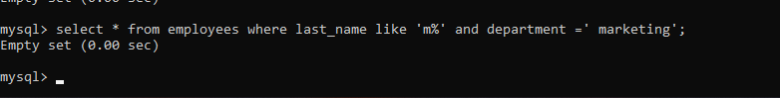

32. Write a query to select all the employees who have a first name that starts with the

letter "J" and a last name that starts with the letter "D" and are in the marketing

department or the engineering department.

